Ferreira, Chris (from Linked In)
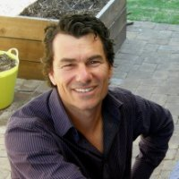

Kwinana Senior High School 1979 – 1983. B.Sc. (Forestry) ANU 1985-1988.

Sustainability Advocate The Forever Project/ Landcare Solutions 1991 – . Sustainability Advocate Self-employed 1991 – . Landcare Planner Green Skills Inc 1996 – 1999. Adjunct Lecturer in Sustainability (Dept Arts) Murdoch University 2013 – . Murdoch Main Campus.

